Sanitation Reality

**Access to Safely Managed Sanitation**Only about **31%** of Kenyans have access to safely managed sanitation services (JMP 2023).JMP 2023

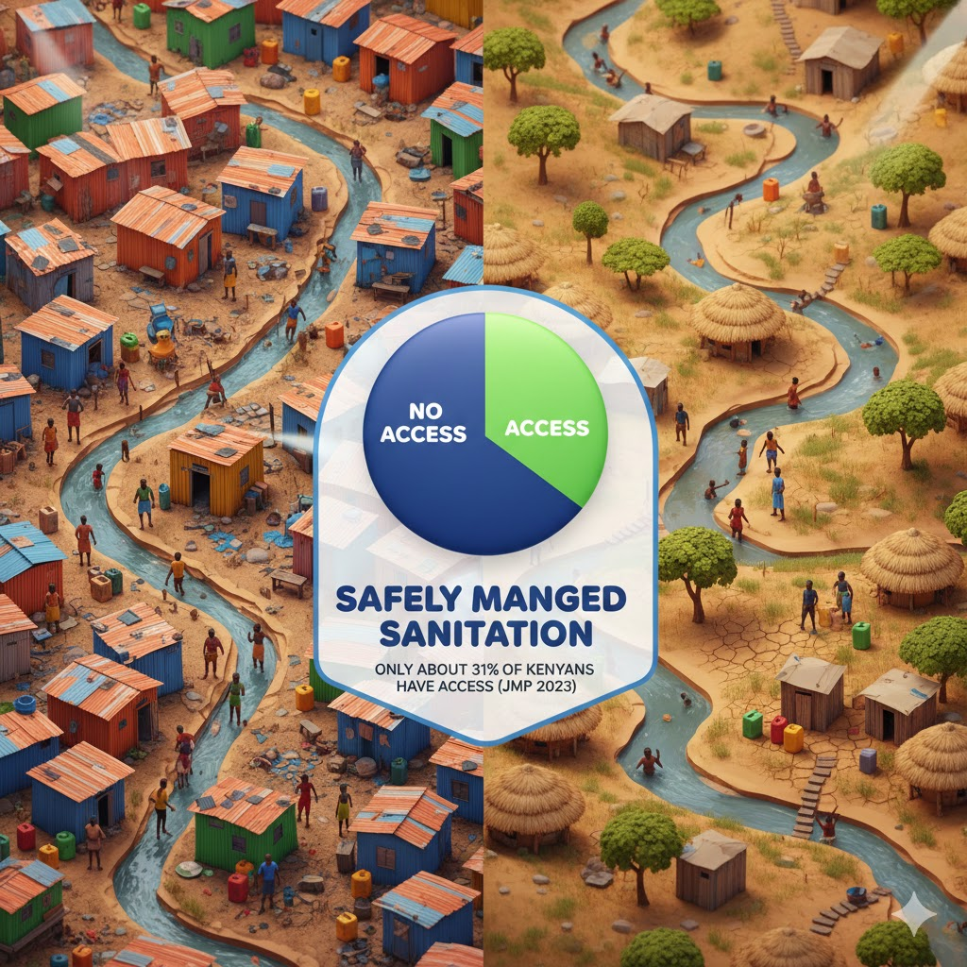

Kenya's Battle with Fecal Waste

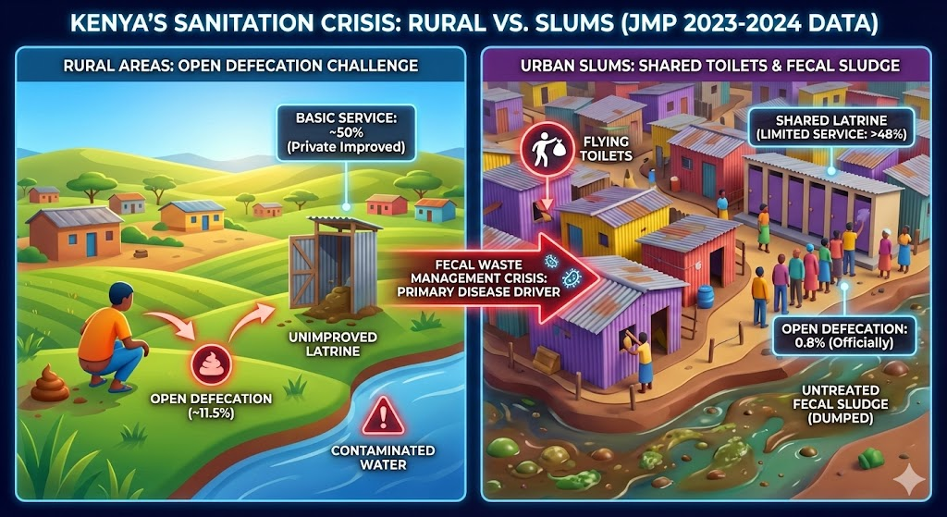

"In Kenya, the fight against disease is ultimately a fight against fecal waste, but the battleground changes drastically depending on where you stand.

In the **rural villages**, the crisis is one of absence: **11.5%** of the population still has no facility at all, forcing over 4 million people to practice open defecation, directly contaminating the land and water sources they rely on.

But move to the **urban slums**, and the statistics mask a darker reality. While official data claims open defecation is under **1%**, this hides the 'limited sanitation' trap. In reality, nearly half the urban population—**48%**—relies on shared, often overflowing latrines where waste is neither contained nor treated. Whether in the open bush or a crowded slum, the result is the same: communities are living amidst their own waste, fueling a preventable cycle of disease."

**Investing in Dignity: Kenya's National Sanitation Management Policy**

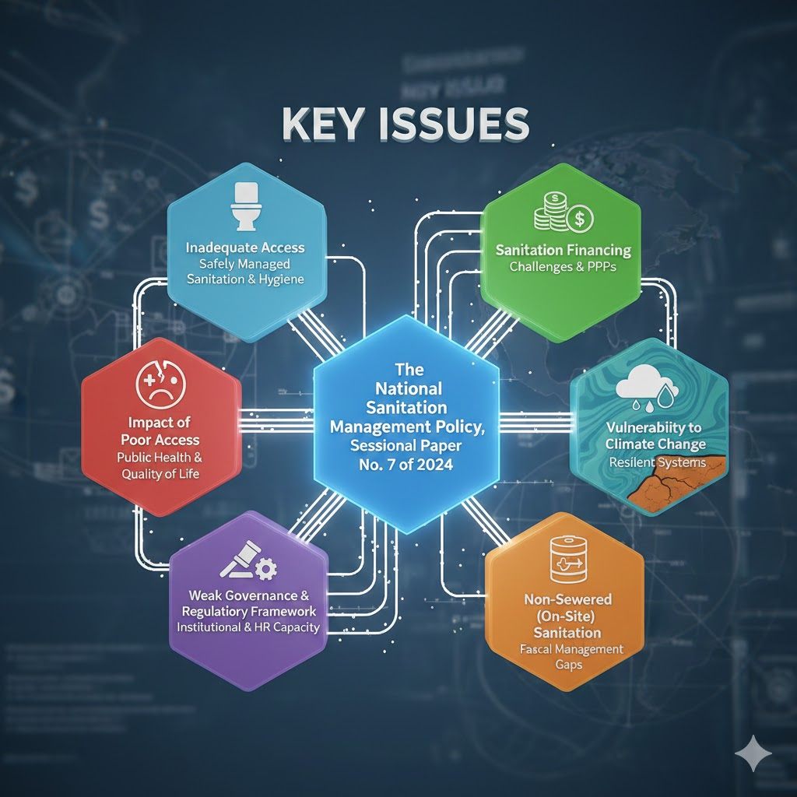

**Investing in Dignity: Kenya's National Sanitation Management Policy**

Kenya's National Sanitation Management Policy (Sessional Paper No. 7 of 2024) is the blueprint for achieving safely managed sanitation for all by 2030, a constitutional right and a crucial step toward public health and environmental protection. It shifts focus from merely basic access to managing the entire service chain—from ensuring safe containment and ending open defecation to integrating non-sewered solutions, promoting gender and disability-friendly facilities, and establishing sustainable financing. The policy is a national commitment to leveraging resilient technologies and strong governance to transform sanitation into an engine for national prosperity and dignity.

**Move hearts and minds: Image speaks**

Be **the change!** Join our revolutionary visual campaign today and let your single, powerful photo be the spark that ignites a global movement. **Give a voice to the voiceless,** turning visibility into action. Because when we unite, we can **make history** and build a better world, **one drop at a time! Upload a photo:**

**Upload a Compelling photograph to Make the Invisible Visible:**

**Include the following: Year**

**2. Specific Location: Country, County, Community/Village Name:**

**3. Description/Caption (Concise summary of the sanitation context shown):** *(What exactly are we looking at? E.g., an exposure, community led intervention, etc.*

**4. Credit/Photographer:** *(Your Name or the Name of the individual who took the photo)*

**5. Informed Consent and Approved Use Confirmation:**

* **Confirmation of Consent:** I confirm that I have obtained explicit, verbal and/or written consent from all identifiable individuals in this photograph to be included in this project’s documentation. (Yes/No): **[INSERT YES or NO]**
* **Approved Use Case:** This photograph is approved for the following purposes: **Advocacy, Non-Commercial Educational Materials, and Internal Project Reporting.**

**Thank you for your valuable contribution!**